EARTHQUAKE PREDICTION

MODEL USING PYTHON(PHASE-4)

Introduction:

Certainly, here's a simplified step-by-step guide for building a basic earthquake prediction model in Python. This will provide a simplified example for educational purposes, but keep in mind that real-world earthquake prediction is a complex and ongoing research area .We analyze the visualization of map and split the data training and testing.

Algorithm:

Step 1-Data Collection = Gather data on earthquake-related parameters, such as historical seismic activity, geological data, and meteorological conditions. Data collection sources from Kaggle data set.

Step 2-Data Preprocessing = Clean and preprocess the data. This may involve handling missing values, normalizing data, and feature engineering.

Step 3-Feature Selection = Evaluate the date , time

,longitude, latitudes, depth and magnitude.

Step 4-Visualization = Using mpl_toolkits basemap ,show the affects of earthquake in world .

Step 5-Split the Data = Split the dataset into training and testing sets to evaluate the model's performance.

Step 6-Choose a Simple Algorithm = For simplicity, you can start with basic machine learning algorithms like Linear Regression, Decision Trees, or Random Forests. We choose random forest regressors algorithms. Analyze regressor of fit, predict and score.

Step 7- Analyze grid search CV = This s used for find the best fit , worst fit , first fit. We analyze the best fit , first find the grid fit and git object then we find best fit .

Step 8- Tuning and Optimization: Fine-tune the model's hyperparameters and consider different algorithms to improve its performance.

Step 9-Model Training = Train the chosen model on the training data.

Step 10-Model Evaluation = Evaluate the model's performance using appropriate metrics (e.g., Mean Absolute Error, Root Mean Squared Error) on the test data.

Step 11- Predictions = Use the trained model to make earthquake predictions based on the input data.

Step 12-Monitor = Continuously monitor and update the model as new data becomes available.

Program:

(question of phase 4) 🡪**Phase 4: Development Part 2**

In this part you will continue building your project.

Continue building the earthquake prediction model by:

* Visualizing the data on a world map
* Splitting it into training and testing sets.
* Visualizing the data on a world map

Algorithm:

1. Import the basemap and using google colab.
2. We using toolkits of mpl basemap.
3. Analyse the data set.(longitude,latitudes)
4. Fixe the fig size.
5. Add the title – all affected area.
6. Add the color the different ways to affected by the earthquake.
7. Use function method of drawcoastline (),drawapboundary() and drawcountries().
8. Print the map.

Output:

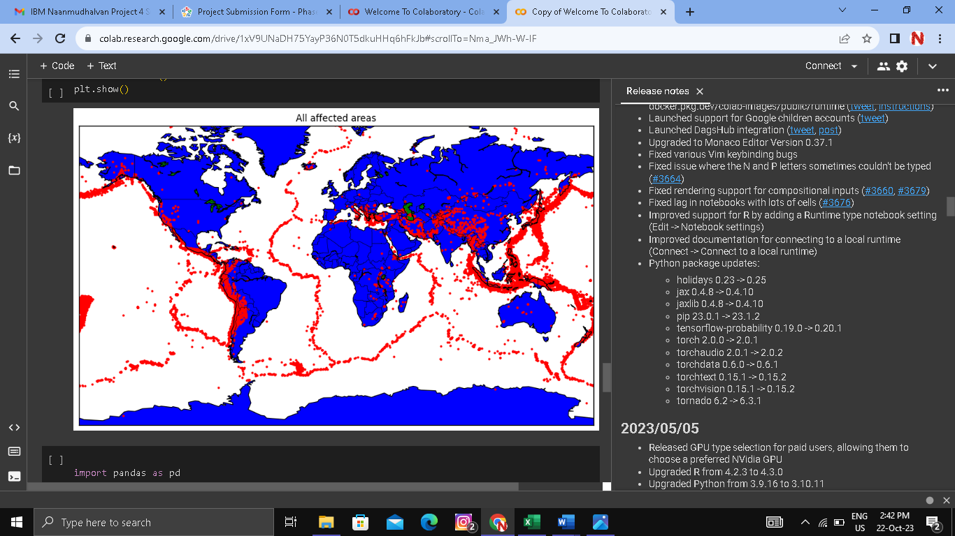

* Splitting it into training and testing sets.

Algorithm:

1. Using google colab to split the data set.
2. First we training the data set.
3. Next we testing the data set.
4. 80% train the dataset and 20% test the dataset.
5. Split the dataset X and y .
6. Train -X and test -y.
7. Print the dataset.

Output:

